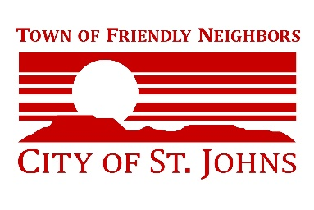


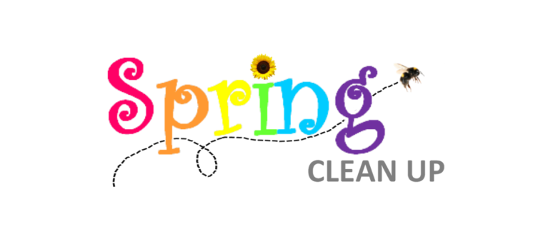

• $5 up to five truck or car loads

PARTNERING WITH
Saturday, May 23, 2026
Take your junk, appliances, and trash to the Blue Hills Regional Landfill on Saturday, May 23, 2026 from 9am—4:45 pm
You will receive large discounts on the cost of disposal:
• $5 up to five truck or car loads
• $15 additional charge for trailers
• $5 per appliance
You must present your May water bill to receive these discounts.,
For more information contact City Hall 928-337-4517

