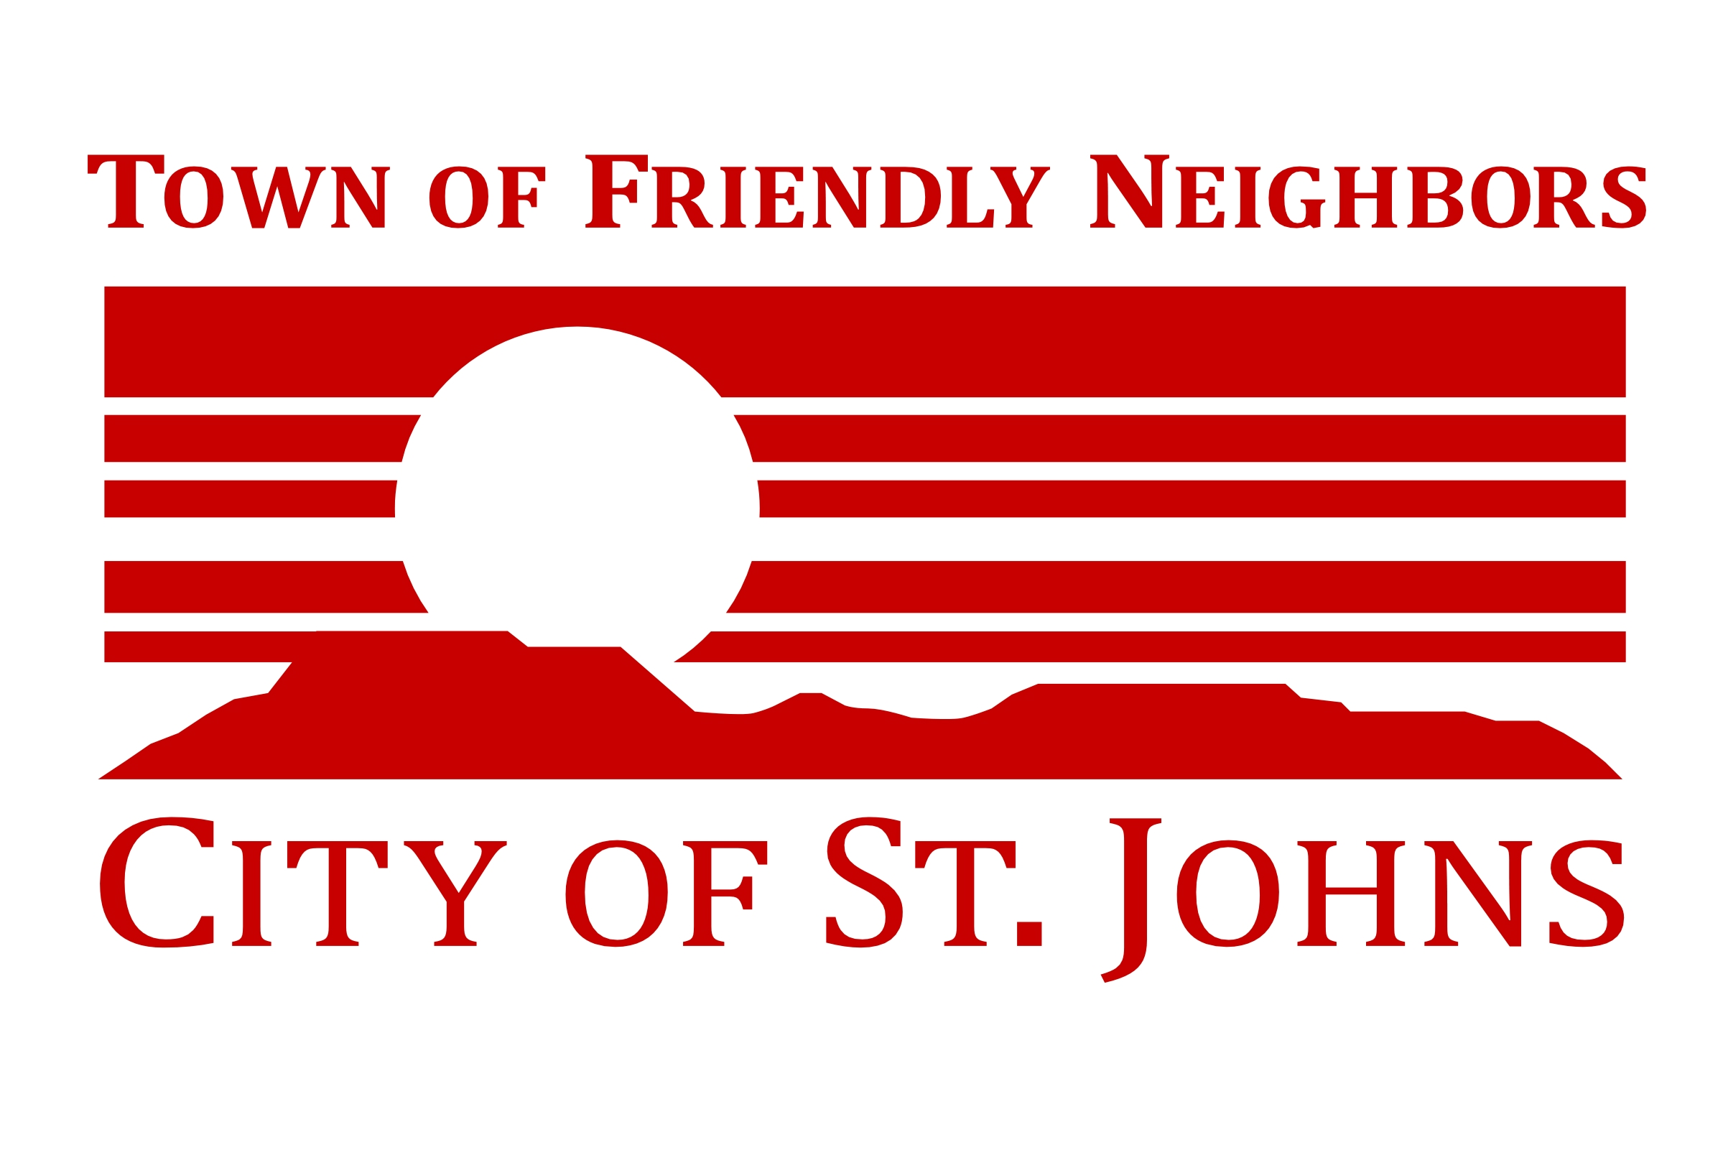

**S**

**NOTICE OF POSSIBLE QUORUM**

**OF THE**

**ST. JOHNS CITY COUNCIL**

Pursuant to A.R.S. § 38-431.02, notice is hereby given that FOUR (4) OR MORE MEMBERS of the St. Johns City Council may be present at the following event:

**Crime Prevention & Neighborhood Watch Community Training**

**Date:** Tuesday, August 5, 2025

**Time:** 7 p.m.

**Location:** St. Johns City Hall

70 E Commercial

St Johns, AZ 85936

NOTE: These events are not an official or unofficial City Council meeting. No official business will be conducted, or any official action taken.