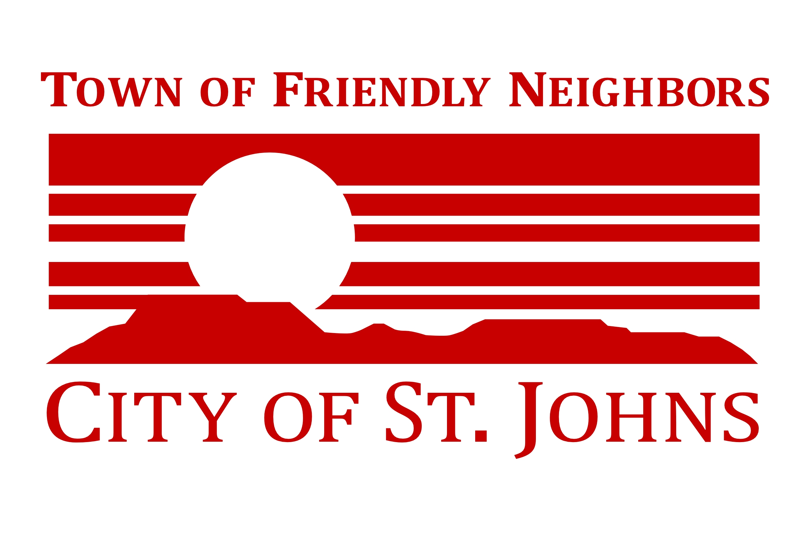
S

NOTICE OF POSSIBLE QUORUM
OF THE
ST. JOHNS CITY COUNCIL

Pursuant to A.R.S. § 38-431.02, notice is hereby given that FOUR (4) OR MORE MEMBERS of the St. Johns City Council may be present at the following event:

Discussion with Senators Staff

Date: Tuesday, July 15, 2025
Location: 70 E Commercial
St. Johns, AZ 85936

NOTE: These events are not an official or unofficial City Council meeting. No official business will be conducted or any official action taken.

