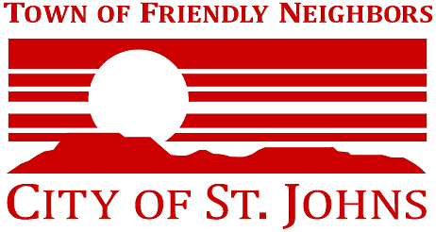
UPDATED
AGENDA

CITY COUNCIL
REGULAR MEETING AGENDA
Wednesday, August 11, 2021
6:30 PM

City of St. Johns Council Chambers
70 E. Commercial
St. Johns, AZ 85936

Spence Udall, Mayor Tony Lindsey, Councilmember Danny Price, Councilmember
Tony Raykovitz, Vice Mayor Ken Whiting, Councilmember Joe Greene, Councilmember
Tanya Cohen, Councilmember

Pursuant to A.R.S. § 38-431-02, notice is hereby given to the St. Johns City Council and to the general public that a meeting will be held, which is open to the public, on the above date and time in the City of St. Johns Council Chambers, 70 E. Commercial, St. Johns, Arizona. The City Council may adjourn into executive session, which will not be open to the public, to obtain legal advice regarding any of the agenda items pursuant to A.R.S. §38-431.03. The items on the following agenda are for information, discussion and possible action.

 | AGENDA ITEM | COUNCIL ACTION
 | CALL TO ORDER
 | INVOCATION AND PLEDGE OF ALLEGIANCE
 | The invocation may be offered by a person of any religion, faith, belief or non-belief, as well as a Councilmember.
 | ROLL CALL
 | CALL TO THE PUBLIC
 | This time is reserved for members of the public to comment on matters not on the agenda. The Council’s response is limited to responding to criticism, asking staff to review a matter commented upon, or asking that a matter be put on a future agenda. Please try to limit comments to 3 minutes or less.
 | CONSENT AGENDA
 | All items listed below are considered consent agenda items and may be approved under a single motion unless removed at the request of Council for further discussion/action.
1. | Consider approval of July 14, 2021 City Council minutes and July 24, 2021 Emergency City Council minutes. | DISCUSSION/ACTION
2. | Request approval for payment of bills from July 1-31, 2021. Special details of bills can be requested at City Hall. | DISCUSSION/ACTION
 | REGULAR AGENDA
3. | Police Department requests approval of the modified IGA between Northeastern Arizona Law Enforcement Training Academy and the Navajo County Community College District to provide basic training and advanced officer training for the St. Johns Police Department. Chief Lance Spivey | DISCUSSION/ACTION
4. | Consider approval of the Police Dept. Fee Schedule changes. Lance Spivey | DISCUSSION/ACTION
5. | Consider approval for the GOHS Grants awarded to the St. Johns Police Dept. for Federal Year 2022. Lance Spivey | DISCUSSION/ACTION
6. | Consider the approval to purchase a Polaris UTV from Polaris Government Sales, using the Sourcewell Cooperative Purchase agreement, not to exceed $40,000. Jason Kirk | DISCUSSION/ACTION
7. | Consider revised City of St. Johns Fiscal Policy and Procedure Manual to include section 9. Cash Disbursements, E; 8. Credit Cards and Purchasing for Wildland Fire and Emergency Response. Jason Kirk | DISCUSSION/ACTION
 | CITY MANAGER REPORT | INFORMATION
 | CITY POLICE CHIEF REPORT | INFORMATION
 | COMMUNITY DEVELOPMENT DIRECTOR REPORT | INFORMATION
 | FIRE AND EMS REPORT | INFORMATION
 | FUTURE AGENDA ITEMS | DISCUSSION
 | The Council may discuss dates and general topics for future meetings. | INFORMATION/DISCUSSION
 | ADJOURNMENT

